First Evidence LPR Service Control

Software Version 3.0.1
18 September, 2009

Contents

System Overview 2
Configuring Watch Lists 3
Configure Email Settings 5
Configure GPS 7
Configure Source Channels 8
Configure Passwords 9
Video Setup 10
LPR Service 11

System Overview

The First Evidence LPR Service Control application is a tool which allows the user to configure and install the LPR Service. The LPR/DVR/Watch-list processing software runs as a Windows Service, which means it runs as a background task with no user interface. The LPR Service Control application is used to configure, install, and start/stop the service. Once the service is configured and started, the LPR Service Control can be closed and should not need to be run very often.
NOTE: When it comes to services, the term “install” has two meanings in the Windows OS. First the service, and all applications must be installed on the hard drive using the setup.exe program for the application. Additionally, for services, the service must be “installed” as a service (i.e. background task). So please be sure to install the service on the hard disk first, using the LPRService/setup.exe program. Then you can install the LPR Service as a “service” using this LPR Service Control program.

The steps to configuring and installing the service are (assumes all First Evidence programs have been installed on the hard disk first, using the respective setup.exe programs) :
- On the Watch List tab- create the watch lists (or skip if not being used).
- On the Email tab, configure the email server (or skip if watch lists are not being used).
- On the Source Channels tab, assign names to all camera’s that will be used.
- On the Passwords tab, assign login passwords (NOTE: This can be skipped for the NCIS version since password login has been disabled at the request of NCIS).
- On the Video Setup tab, choose NTSC or PAL as appropriate for the camera types being used.
- On the LPR Service tab, install the LPR service.
If changes are made to any of the configuration settings after the LPR Service is started, you must stop the service and restart it (on the LPR Service Tab).

Configuring Watch Lists

The watch lists are stored in a text file that you create, or have exported from a database or spreadsheet. The contents of the watch list take the form:

456XYZ, STOLEN VEHICLE, WHT FORD EXPLORER, YR 2002

The text before the first comma is understood to be the plate number being watched for, the remainder of the text after that is understood to be commentary that is transmitted in watch alerts.

Once the watch list file has been selected, it should not be moved. The PSS will watch for changes to that list’s contents and automatically re-load the list when the change is detected. This allows you to automatically push new watch list updates to the system from a database.

Note: watch list processing is momentarily suspended when these updates occur, so they should not be too often. Once per day is typical.

A sample watch list has been provided, along with a sample video. Select the Configure menu item then select the Watch List item. The Watch list control page will appear.

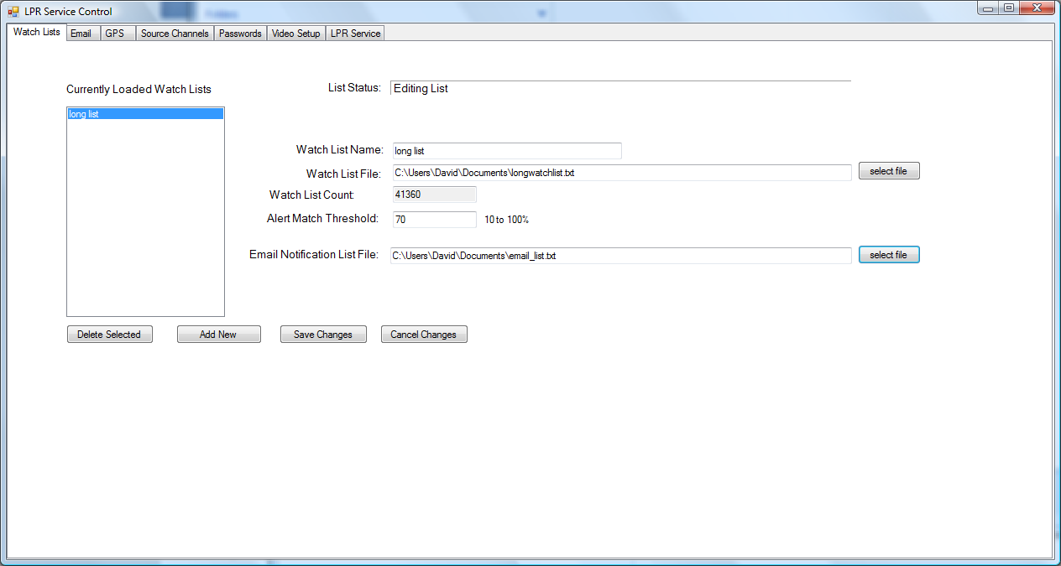

Select “Add New” and a new watch list is created. You can then edit the name.

Next to the watch list file box, click the “select file” button. When the PSS is first run, this file selection will automatically lead you to the sample watch list provided:

watchlist_example_UK_motorway.txt

Select this file. Now when you also select a video source of “video file”, you will be given the option to select the video clip sample that accompanies this watch list file. This watch list file contains all the plate numbers which occur in the video clip.

The “Alert Match Threshold” is a value which is used by the Smart Search technology when determining if a match exits. A setting between 70 and 75% typically results in rare false positives but a very high correct match rate.

The email notification list is a text file which you create which contains a list of email addresses to notify when a watch list match is detected. The email will contain match details and a jpeg image. The contents of the email notification file should be of the format:

bill@yourcompany.com
jim@yourcompany.com
david@yourcompany.com

Unlike the watch list file, changes to this file are Not automatically detected by the LPR Service. The Service should be stopped and re-started if this list is changed after the service has been installed.

Email notifications will not be sent until the email server details are configured.

To have different groups of people notified on different sets of plates, simply create multiple watch lists and multiple email lists. You can configure one email list for each watch list.

Configure Email Settings

The Email settings allow the PSS to send emails via your preferred email POP3 server.

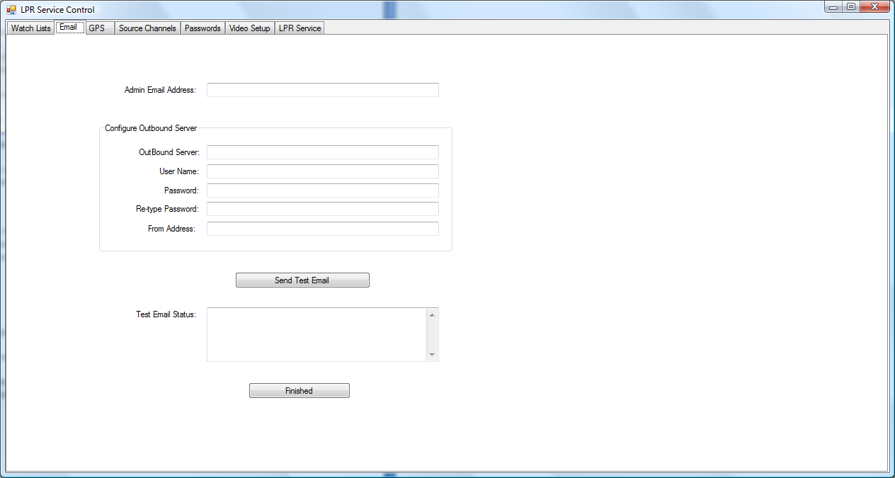

The User Name field is the user name on the email account which will be used to send emails. Your IT department needs to create a user name on your email server for this purpose. You can create one user name for all deployments of PSS to use, or you can create a unique user name for each deployment. Additionally, you can use your own personal email account settings here, in which case, it will appear that the alert emails are coming from you.

The password is the password associated with the user name on the email server. The password is stored on the local disk drive in encrypted format. DES-3 is used for encryption.

Outbound Server is the email server you will use.

From address is the address that appears in the ‘from’ field in all emails generated by the PSS. Typically, this is the same as the username.

Admin Address is the email address to which health status emails will be sent.

When you have completed entering all the fields, click Send Test Message. This will automatically send out a test email to the Admin address. The status line will indicate success or failure; The PSS can detect some email send errors, but many email errors will be reported as ‘bounce backs’ sometime later. Look for the received emails in the target email accounts and also look for bounce backs in the inbox used as the ‘from’ address (the ‘from’ address is setup in the email server configuration page). If the admin does not receive the test message, then there is a problem in one of the fields, or your service account is not properly setup. Double check that the account user name and ‘from’ addresses are setup in the server.

Click Finished when done.

Configure GPS

If the First Evidence GPS USB Receiver is used, no configuration is necessary. Follow the directions on the GPS CD for installing the GPS driver, then plug in the GPS receiver. It will be automatically detected.

If the GPS receive is not used, you have the option to set the fixed site coordinates manually. You may enter the location either in Degrees/Minutes/Seconds format or in Degrees.fractional-degrees format.

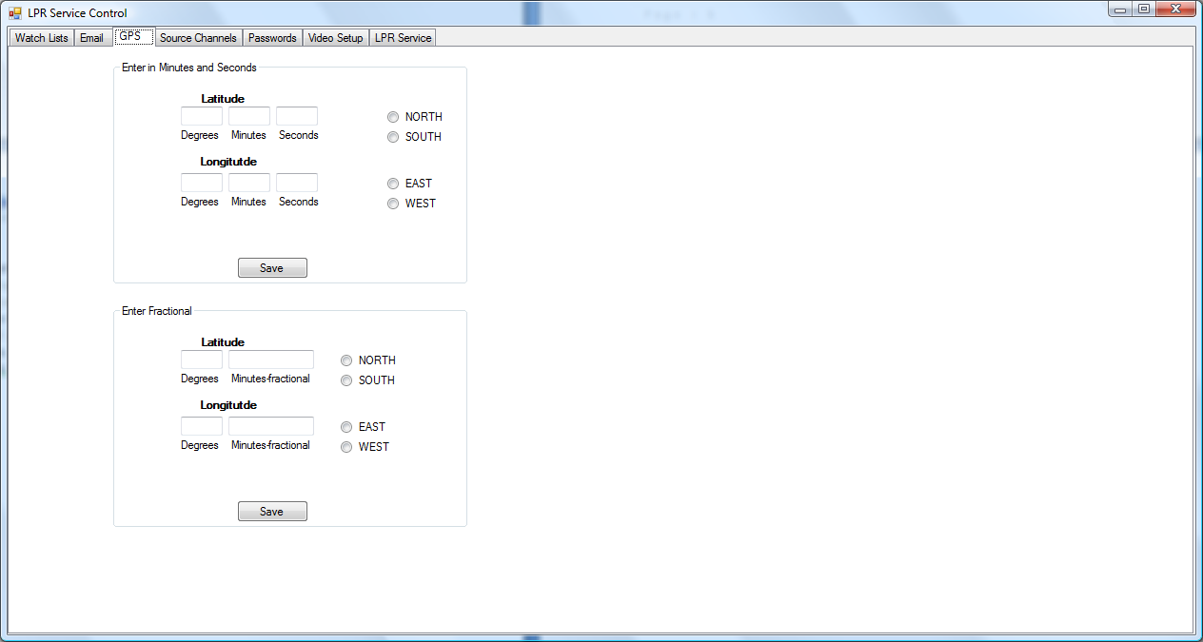

Configure Source Channels

Use this tab to provide names for the camera sources. If a camera is not named, it will not be enabled.

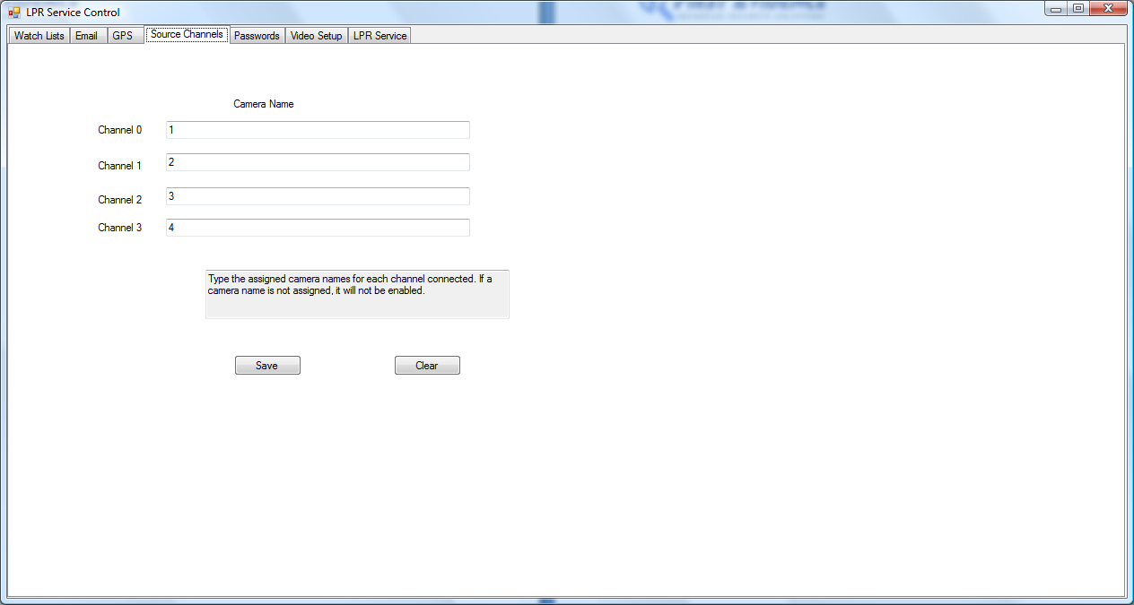

Configure Passwords

Passwords are used by the LPR Service to allow/deny access to the video streams from LPR Monitor Application users.
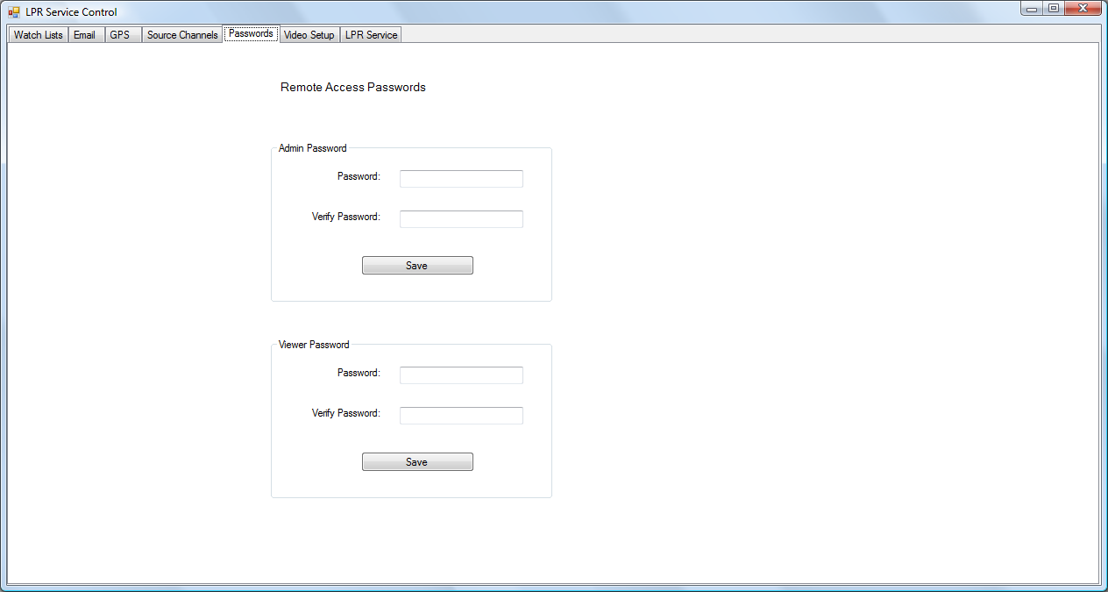

Video Setup

Choose the camera signal type (NTSC – used in the USA and some other countries, PAL – used in Europe and many other countries).

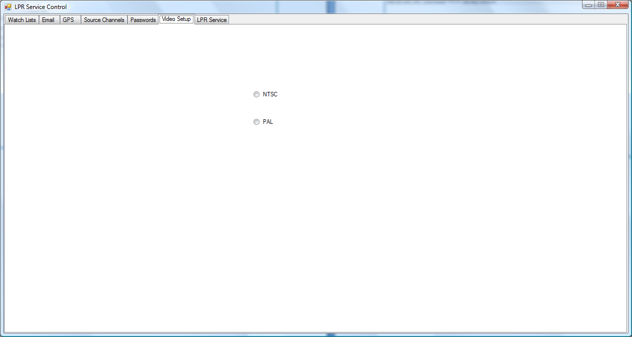

LPR Service

Use this tab to install and start the LPR service (be sure to install it on the hard drive first using the LPRService/setup.exe file). Click on Install. After 5 to 10 seconds the status indicator should automatically change from Not Running to Running. If changes are made to any of the configuration settings, use the Stop Service/Start Service toggle button to re-start the service.
The LPR Service will automatically start when the computer is booted.
You should not need to use the LPT Service Control application again unless one of the settings needs to change.

